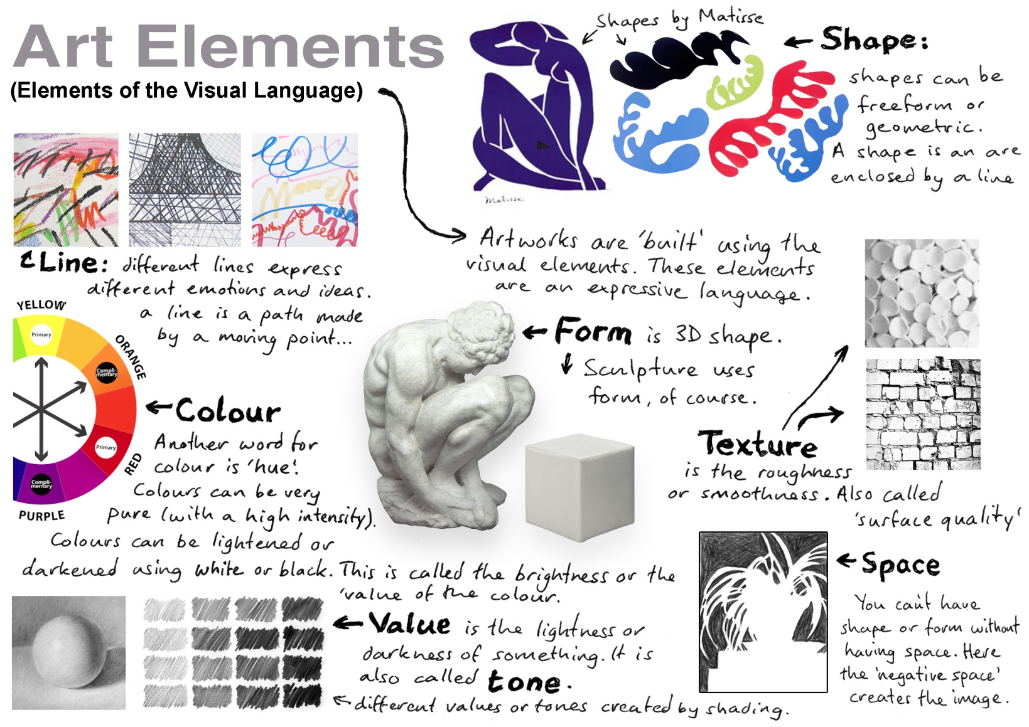
Principles of Design- How we organize and place the parts in our artwork

- Balance- Visual weight of objects looks equal- symmetrical and asymmetrical balance

- Contrast- Difference in size, shape, value, color, texture, line (High and low contrast)

- Variety-Many different lines, shapes, colors, patterns, textures, values used in a design

- Emphasis- Something stands out in your design- Important elements are put in center or made bigger- make something the focus of your design

- Repetition/Pattern- Repeating lines, patterns, values, colors, shapes

- Rhythm/Movement- Creating movement from one element to the next in your artwork- repeating, spacing and varying elements to create rhythm like in music

You hope to make:

Unity- when everything in your composition is in a good place using the other principles of design- your artwork looks complete and finished

