7th Grade Visual Arts Units

1. Color influences (affects) us. Exploration into color- theme & variation, positive/negative designs, creative paper weaving, paper-cut with layers
Elements & Principles | Essential Questions | Other Ideas
Color- primary, secondary, complem. | How does color influence us? | Theme & variation- positive/negative designs
Contrast, Unity, Balance- radial symmetry | How can we creatively use color? | Radial symmetry designs and watercolor- weaving
 |  | Chinese paper cut- layering
 |  | Stencil Skyline- positive/negative- warm and cool colors

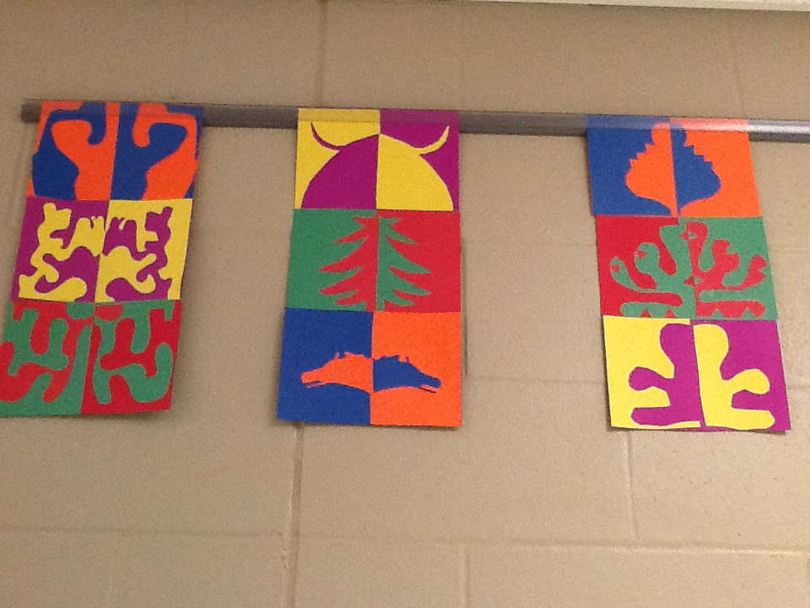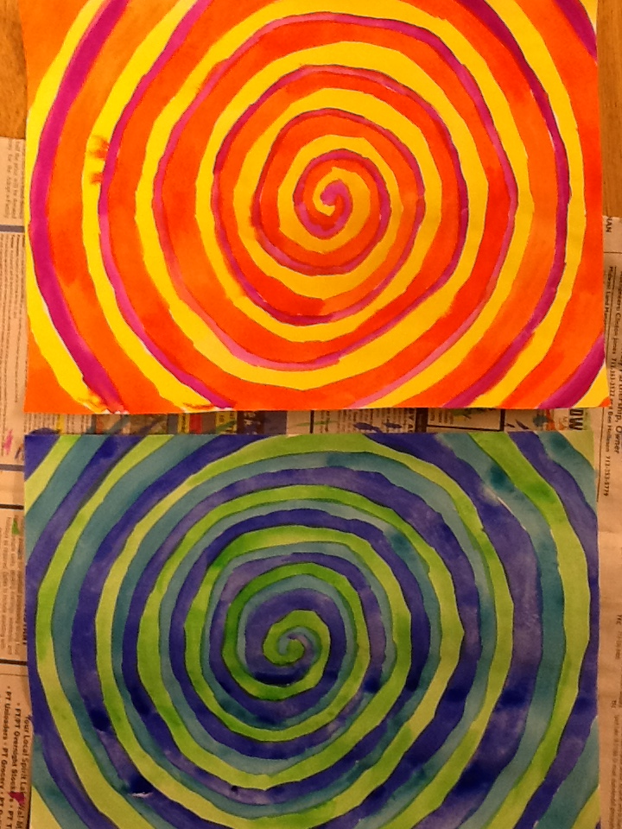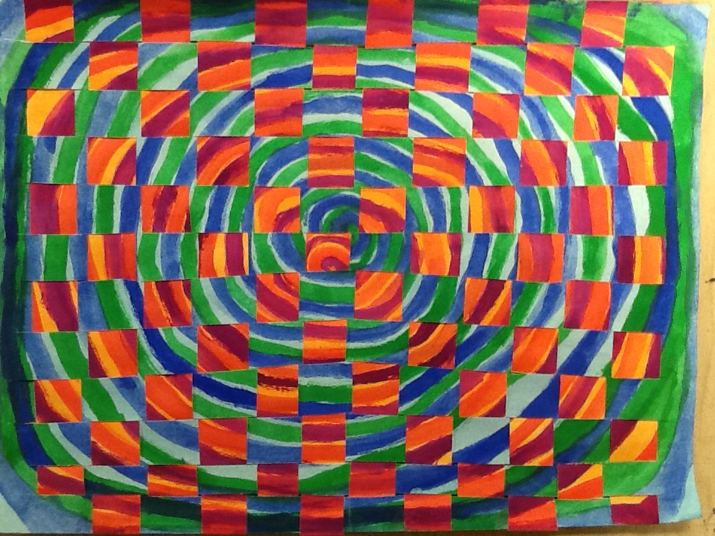
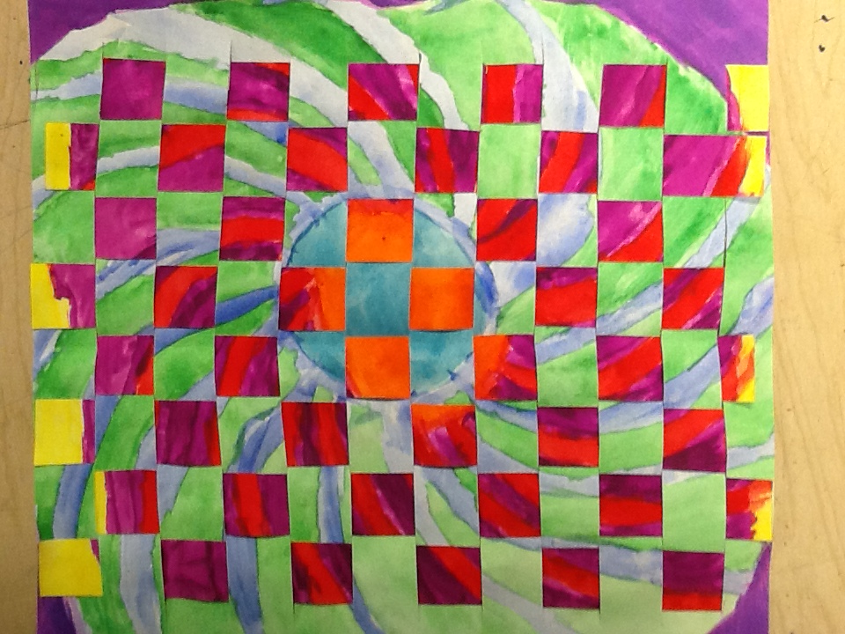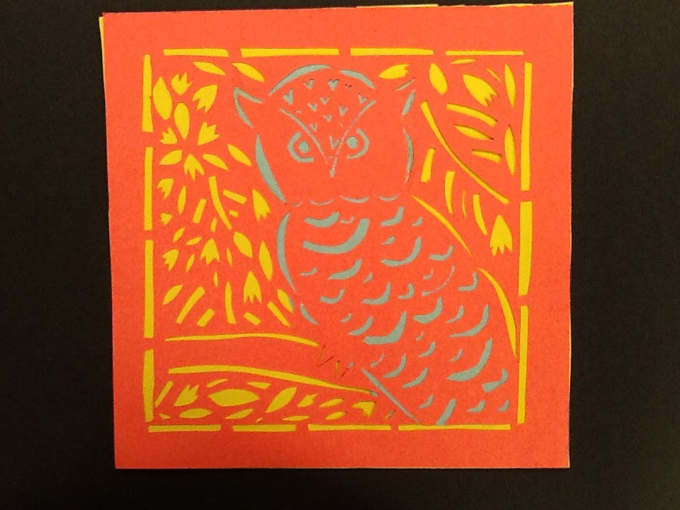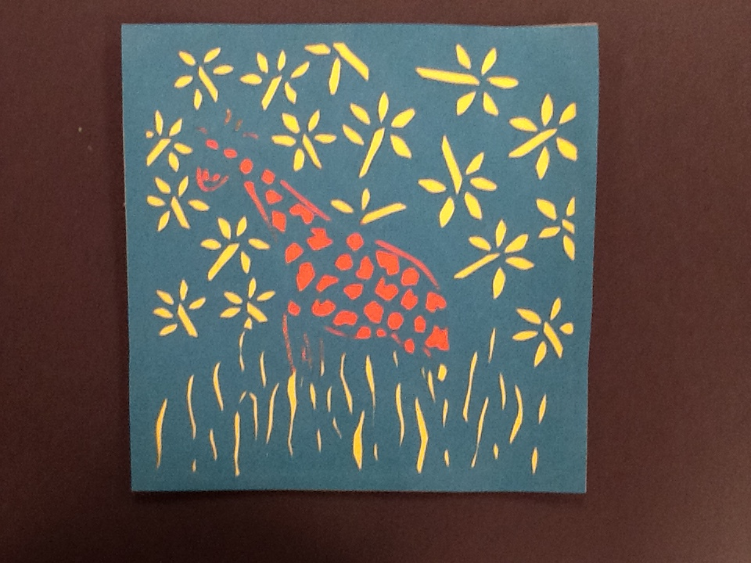

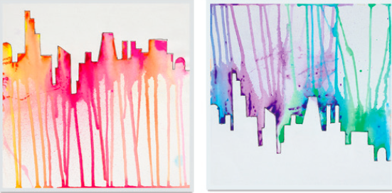

2. Pop culture affects us.
Pop art portrait and clay jar
Elements & Principles | Essential Questions | Other Ideas
Color, form, texture | How does pop culture affect us? | Roy Lichtenstein-portrait with dots and speech bubble
Repetition, Emphasis | What is popular to me now? | Clay jar with pop culture icon as head- like Egyptian canopic jars
 | How can we express our fascination with popular culture? | Takashi Murakami- soft sculpture- monster
 | 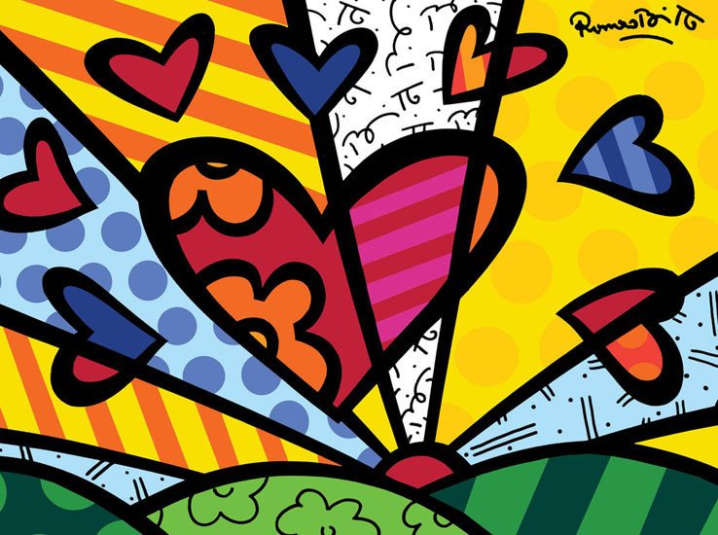 | Romero Britto- contemporary art- combines cubist style of Picasso and vibrant colors/patterns of Matisse

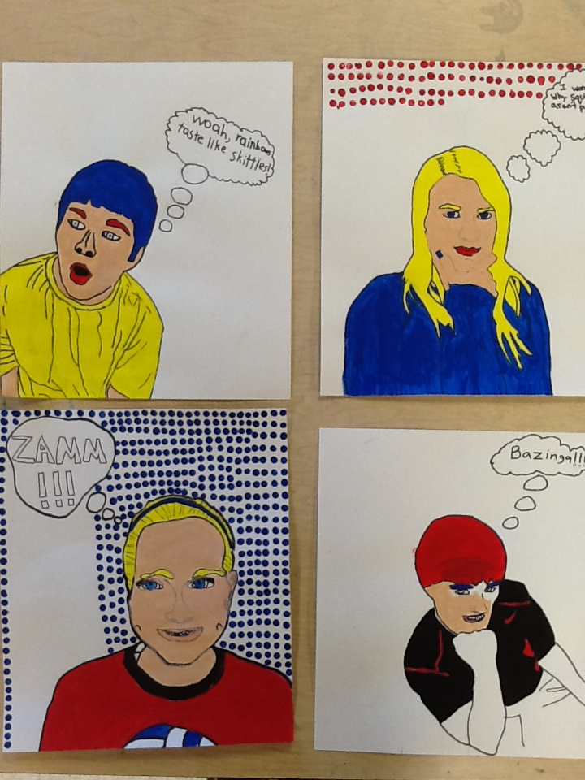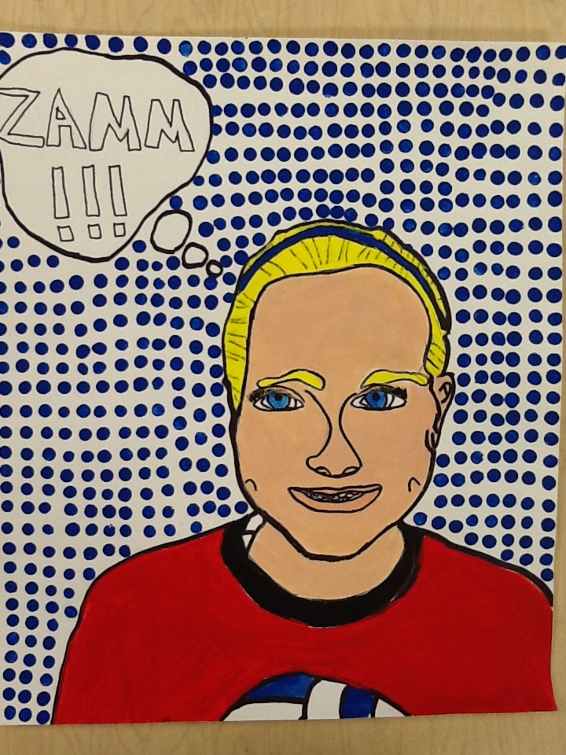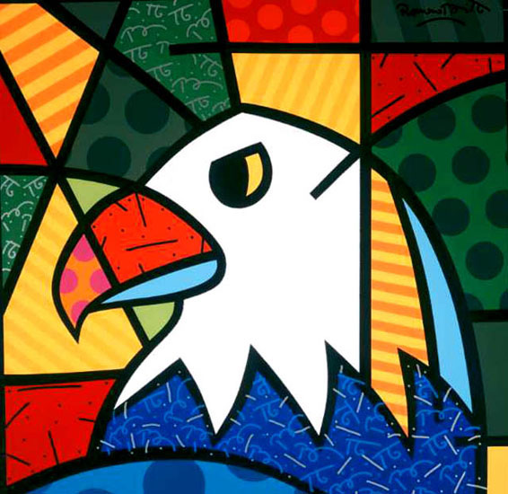

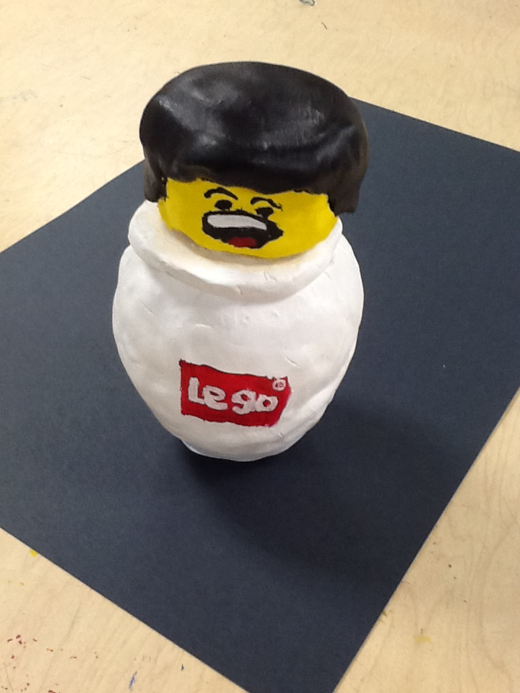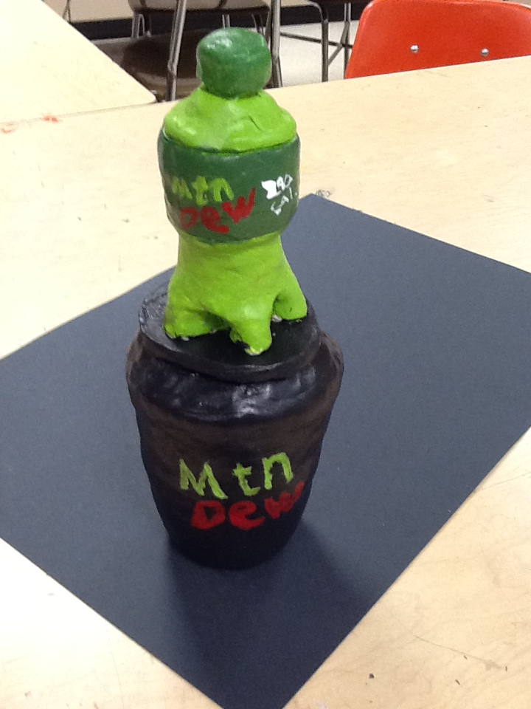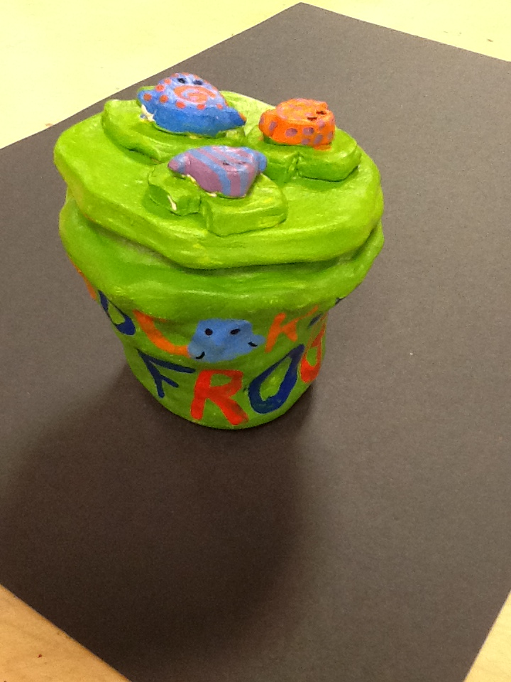

3. Math + art = Smart☺
Math can help us create something.
Elements & Principles | Essential Questions | Other Ideas
Shape, line | How are math and art related? | Discovery of art and math- tesselations
Repetition, pattern | Can art be exact? | M.C. Escher
 |  | Tesselation video

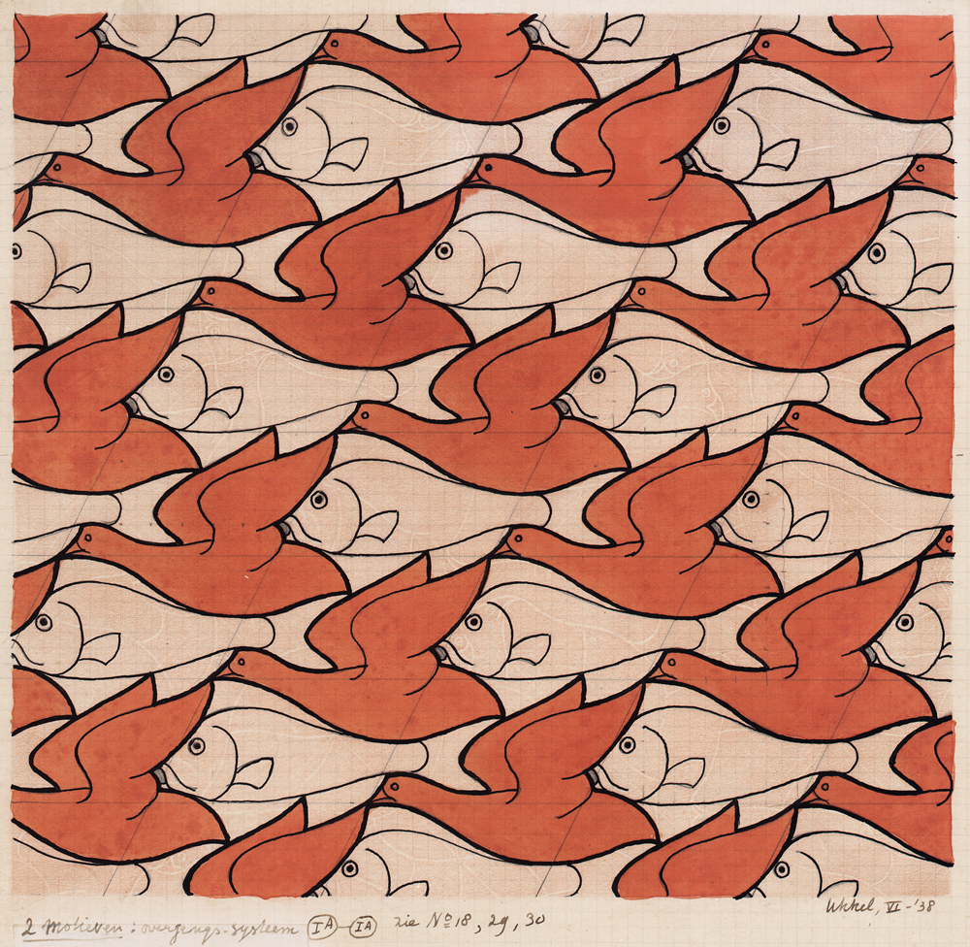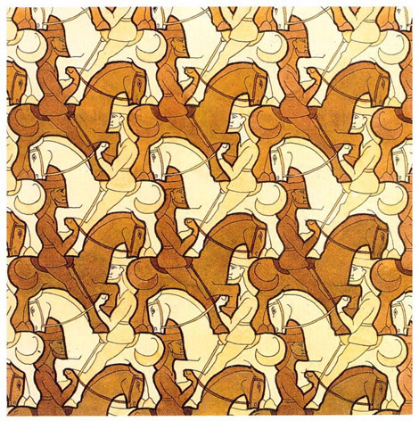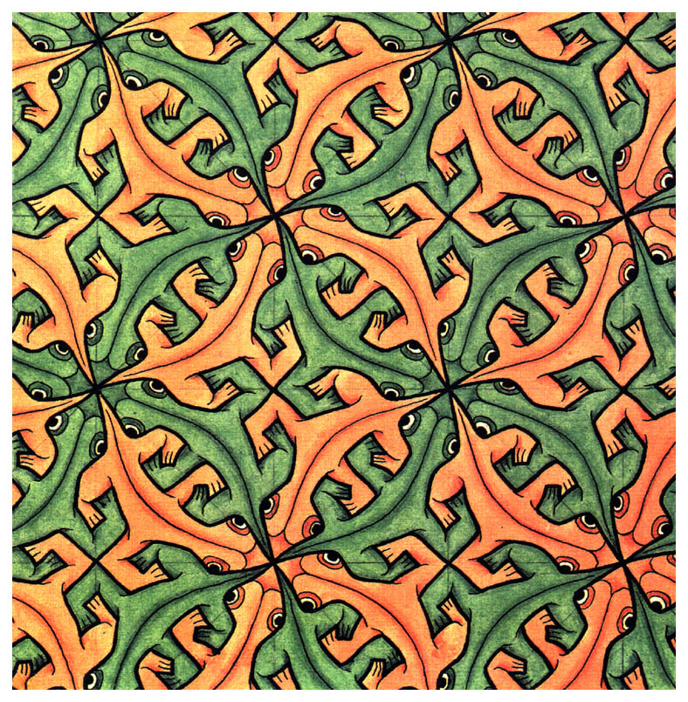
4. Henna Design and History
Culture influences our individual expression.
Elements & Principles | Essential Questions | Other Ideas
Line | How are cultures different? | India art- bold lines and patterns- Henna
Pattern, Variety, Contrast | What can we learn from other artists? | Markers  Plaster hand- paint
 | What can we create with lines & patterns? | Creating with lines…doodling… line art

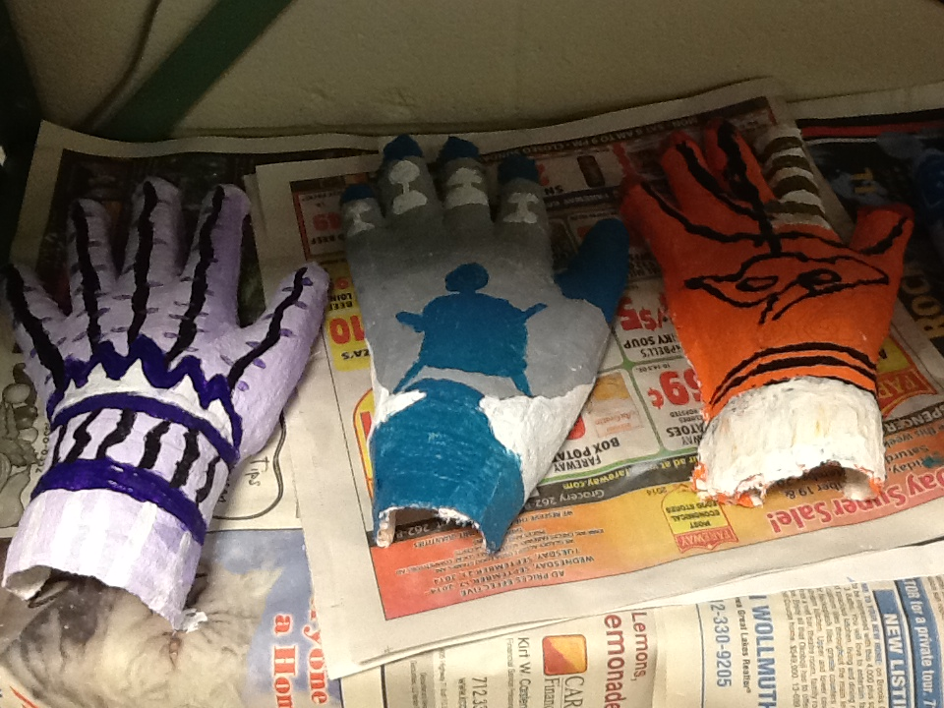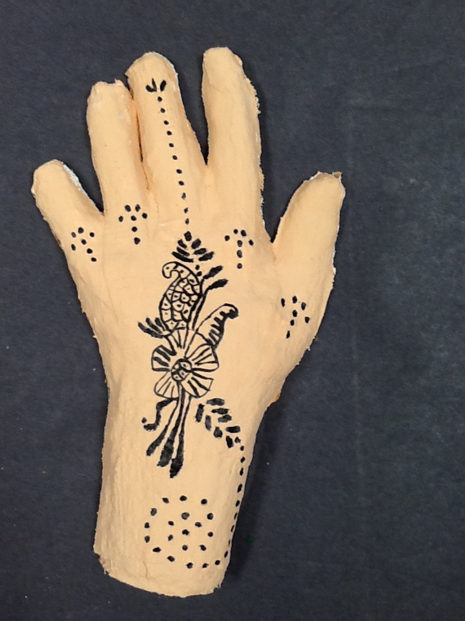
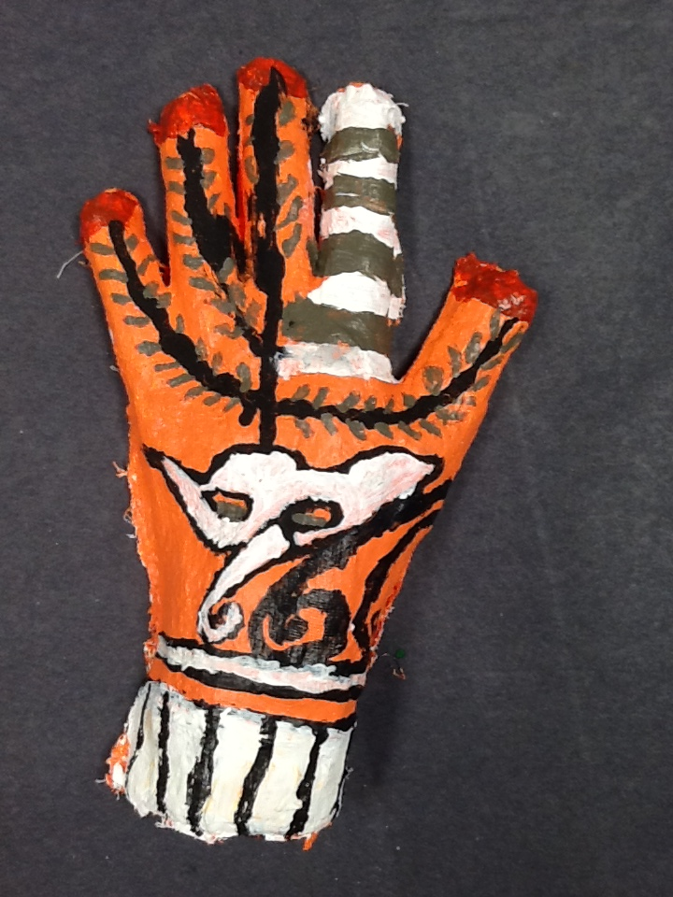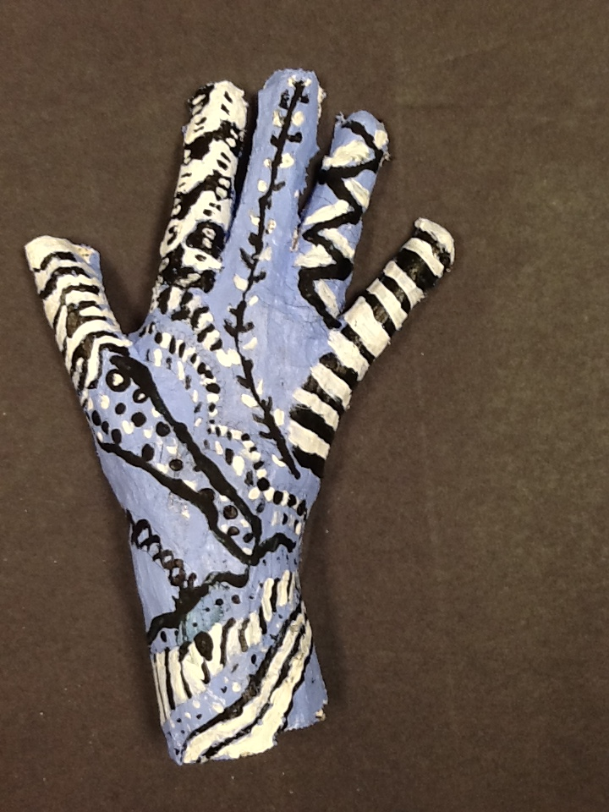

5. Evolution of an Idea- cut paper design and box sculpture
Forms evolve over time.
Elements & Principles | Essential Questions | Other Ideas
Form, Space | Is change always good? | Nevelson, Barbara Hepworth
Variety, Balance, Unity | How do I affect my environments? | Theme and variation, Environment
 | Why do we represent something in an abstract way? | COLLECT BOXES!!!



